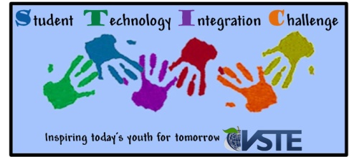
STIC Multi-media Contest Information 2012

Expectations and Guidelines:
- In order to be classified as a multimedia project, entries should include two or more of the following features:
- Text
- Graphics
- Animation
- Audio and / or video
- Sponsors may submit up to 2 entries for the Multimedia Contest per grade level categories.
- Lead sponsoring teacher must be a member of VSTE.
- Grade level categories are Pre-Kindergarten-2, 3-5, 6-8, 9-12
- One winner will be selected per grade level category.
- Individual and group entries will be accepted, but groups are limited to 5 students.
- Only students attending schools in the state of Virginia are eligible to participate in this contest.
- All entries must have been completed between April 2011 and October 1, 2012
- All entries must be available for viewing via the Internet.
- All submissions must be self-extracting (contain a player) if applicable.
- Approved Software Packages include, but are not limited to the following: Pixie, Photostory, PowerPoint, Windows Movie Maker, iMovie, KidPix, or Keynote.
- A completed entry form must accompany all entries.
- If any material is copyrighted, please attach authorization for its use. Beware of copyright-complete music clips are considered copyright protected and may not be used in a winning product.
- One free registration to the VSTE conference will be awarded to each winner’s lead teacher sponsor.
- Student winners and their teacher from each grade level category will receive a prize that will be awarded at the VSTE conference during an afternoon ceremony on Sunday, December 2, 2012.

Not a member of VSTE?
Sign up now to participate in the contest.
http://www.vste.org

